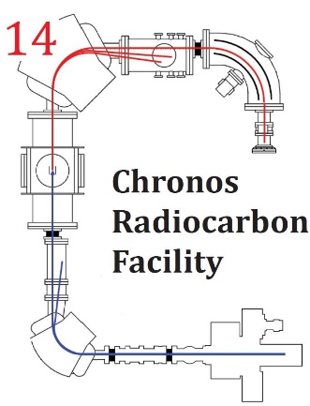

Submission for Radiocarbon Analysis

Principal Investigator
Address
Phone No.
Email
Submission date

Other personnel involved in project (co-investigators, students, staff, etc.)
Name and Contact Information:

Research Project Title:
Nature of Project (Pilot study/tests, New, Continuing, Consulting):

Essential Sample information
Analyses Requested
Radiocarbon and/or
Carbon/Nitrogen stable isotopes
Sample name  (ie. text on label) | Sample Type (eg. graphite, CO₂, peat, sediment, soil, plant, wood, charcoal, clay, shell, etc) | Entire sample submitted (Y/N)?
For large batches please provide a separate sample list as an Excel or Word file.
Additional Information
Site name and type, eg. marine, terrestrial, lake, cave etc:

Location (latitude and longitude or attach list)

I consent/do not consent to the sample locations being used in Chronos promotional material
Date collected:

Condition of samples at time of collection (e.g. waterlogged):

Possible contaminants (e.g. roots, humic infiltration, conservation agents, preservatives, adhesives):

Estimated age range: (Include basis of estimate)

For sediment samples, please provide carbon % (if known):

Has the sample undergone chemical and/or physical treatment? If yes, please give details.

Do you require analysis of subsamples (e.g. different sediment fractions)? If yes, please give details.

When are results required? If timing is critical, please explain why.

Any other radiocarbon dates or details relevant to this project:

NOTE: Carbon-14 can be used as a synthetic label for biomolecules at levels that represents a major hazard to a radiocarbon dating laboratory. If you work nearby a lab or researcher involved in carbon-14 labelling, please contact us for advice.

Please return to Chronos Radiocarbon Facility:
chronos@unsw.edu.au

Please deliver samples to:
Chronos Radiocarbon Facility
c/o William Hiscock
UNSW Lower Campus Store
School of Chemical Science, Gate 2, High Street
Room GQ13, G, E8 Science and Engineering
UNSW Sydney, Kensington NSW 2033

